**Phase 5 project**

**Project Title: PUBLIC TRANSPORT OPTIMIZATION**

**Project ID: proj_223732_Team_2**

**College: Gnanamani College of Technology**

**Branch: B.Tech/Information Techology**

**Year: IIIrd year**

**College code:6208**

**Team members:**

**S.Jayapriya(620821205022)**

**G.Sneka(620821205053)**

**V.R.Vaishnavidevi(620821205061)**

**P.Gopika(620821205016)**

**Phase-5**

**Public Transport Optimization**

Public transport involves improving the efficiency, reliability, and sustainability of public transportation systems. This can be achieved through various strategies, such as:

1. Route Planning: Optimizing bus, tram, or train routes to serve high-demand areas and reduce unnecessary detours.

2. Frequency Adjustment: Increasing or decreasing service frequency based on demand, reducing wait times for passengers.

3. Real-time Monitoring: Implementing GPS tracking and data analysis to manage and adjust services in real time.

4. Fare Integration: Creating integrated fare systems for seamless transfers between different modes of public transport.

5. Infrastructure Upgrades: Investing in modern infrastructure, like dedicated lanes for buses or tram systems, to reduce congestion and improve reliability.

6. Eco-friendly Solutions: Transitioning to electric or hybrid vehicles to reduce emissions and environmental impact.

7. Accessibility: Ensuring that public transport is accessible to all, including individuals with disabilities.

8. User Experience: Improving passenger amenities, information systems, and safety measures.

9. Public-Private Partnerships: Collaborating with private companies for technology and investment to enhance public transportation.

IoT Device Setup:

Hardware:

1.Memory (RAM): Temporary storage for data and programs that the CPU is currently using.

2.Storage Devices: Such as hard drives and solid-state drives (SSDs) for long-term data storage.

3.Motherboard: The main circuit board that houses the CPU, memory, and other components, providing the connections between them.

4.Graphics Processing Unit (GPU): Specialized hardware for rendering graphics and accelerating tasks like video rendering.

Architecture:

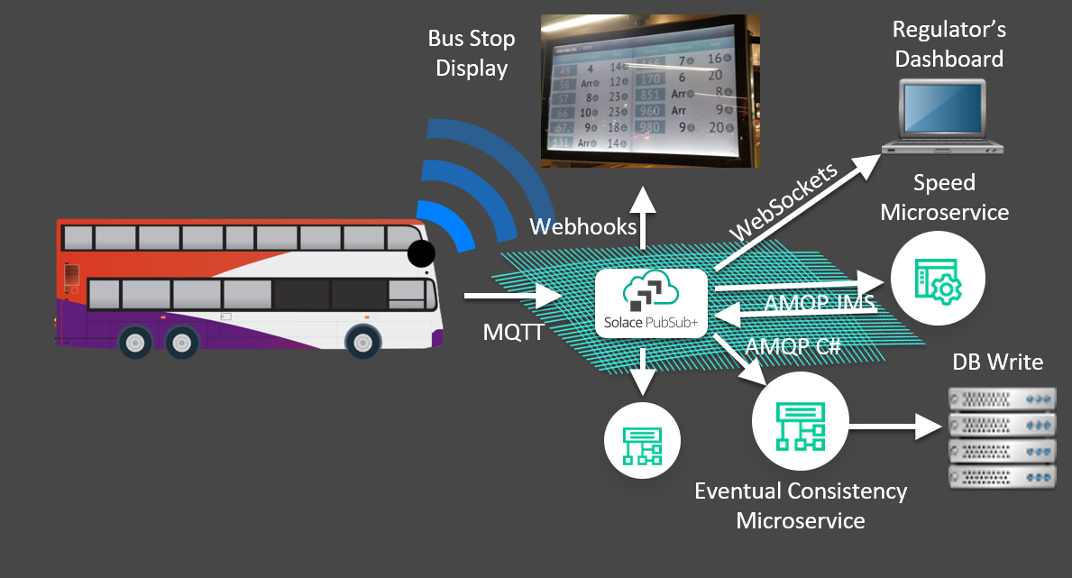

Device Deployment:

Code Implementation:

python:

import paho.mqtt.client as mqtt

import json

import random

import time

# Simulated IoT sensor data

vehicle_id = "bus123"

passenger_count = 0

# Connect to MQTT broker

mqtt_broker = "mqtt.eclipse.org" # Replace with your broker's address

mqtt_port = 1883

mqtt_topic = "transit/realtime_data"

def on_connect(client, userdata, flags, rc):

print(f"Connected with result code {str(rc)}")

client.subscribe(mqtt_topic)

def on_publish(client, userdata, mid):

print("Message Published")

# Initialize MQTT client

client = mqtt.Client()

client.on_connect = on_connect

client.on_publish = on_publish

client.connect(mqtt_broker, mqtt_port, 60)

while True:

# Simulate location data

latitude = round(random.uniform(30.0, 40.0), 6)

longitude = round(random.uniform(-100.0, -90.0), 6)

# Simulate passenger count data

passenger_count += random.randint(0, 5)

# Create a data dictionary

data = {

"vehicle_id": vehicle_id,

"location": {

"latitude": latitude,

"longitude": longitude

},

"passenger_count": passenger_count

}

# Publish data to the MQTT topic

client.publish(mqtt_topic, json.dumps(data))

print("Sent: ", data)

time.sleep(5) # Adjust the interval as needed.

Public Transport Optimization:

Creating a complete public transport optimization system in HTML, CSS, and JavaScript is a complex task that would typically require a back-end server for data processing and storage.

Index.html

<!DOCTYPE html>

<html>

<head>

<title>Public Transport Optimization</title>

<link rel="stylesheet" type="text/css" href="styles.css">

</head>

<body>

<h1>Public Transport Route Planner</h1>

<div id="input-section">

<label for="start-stop">Start Stop:</label>

<input type="text" id="start-stop" placeholder="Enter start stop">

<br>

<label for="end-stop">End Stop:</label>

<input type="text" id="end-stop" placeholder="Enter end stop">

<br>

<button onclick="planRoute()">Plan Route</button>

</div>

<div id="result-section">

<h2>Optimal Route:</h2>

<p id="optimal-route">No route planned yet</p>

</div>

<script src="script.js"></script>

</body>

</html>

Style.css

body {

font-family: Arial, sans-serif;

}

h1 {

text-align: center;

}

#input-section {

margin: 20px;

padding: 20px;

border: 1px solid #ccc;

border-radius: 5px;

}

label {

font-weight: bold;

}

input {

width: 100%;

padding: 5px;

margin: 5px 0;

}

button {

background-color: #007BFF;

color: white;

padding: 10px 20px;

border: none;

border-radius: 5px;

cursor: pointer;

}

#result-section {

display: none;

margin: 20px;

padding: 20px;

border: 1px solid #ccc;

border-radius: 5px;

}

#optimal-route {

font-weight: bold;

}

Script.js

function planRoute() {

const startStop = document.getElementById('start-stop').value;

const endStop = document.getElementById('end-stop').value;

// In a real system, you would make an API call to get the optimal route.

// For this example, we'll use a simple message.

const message = `Start at ${startStop}, take Route X, change at Stop Y, continue to ${endStop}.`;

const resultSection = document.getElementById('result-section');

const optimalRoute = document.getElementById('optimal-route');

optimalRoute.textContent = message;

resultSection.style.display = 'block';

}

Android App(Java)

import androidx.appcompat.app.AppCompatActivity;

import android.os.Bundle;

import android.view.View;

import android.widget.Button;

import android.widget.EditText;

import android.widget.TextView;

public class MainActivity extends AppCompatActivity {

EditText startStopEditText;

EditText endStopEditText;

Button planRouteButton;

TextView resultTextView;

@Override

protected void onCreate(Bundle savedInstanceState) {

super.onCreate(savedInstanceState);

setContentView(R.layout.activity_main);

startStopEditText = findViewById(R.id.startStopEditText);

endStopEditText = findViewById(R.id.endStopEditText);

planRouteButton = findViewById(R.id.planRouteButton);

resultTextView = findViewById(R.id.resultTextView);

planRouteButton.setOnClickListener(new View.OnClickListener() {

@Override

public void onClick(View v) {

String startStop = startStopEditText.getText().toString();

String endStop = endStopEditText.getText().toString();

// In a real system, you would call a route optimization function here.

// For this example, we'll display a simple message.

String message = "Start at " + startStop + ", take Route X, change at Stop Y, continue to " + endStop + ".";

resultTextView.setText(message);

}

});

}

}

Data sharing and public awareness:

Social Issues: Data can be used to raise awareness about various social issues, such as climate change, inequality, and public health.

Education: Data can inform the public about the state of education, funding, and outcomes.

Environmental Awareness: Environmental organizations use data to highlight issues like pollution and habitat loss.

Crisis Management: Data can inform the public during crises, such as natural disasters or public health emergencies.

Conclusion:

The implementation of IoT technology in the public transport system represents a significant step towards enhancing efficiency, reliability, and user experience. By setting up IoT infrastructure, ensuring data connectivity, developing relevant software, and integrating various components, the project can successfully achieve its objectives.Continuous testing, deployment, and maintenance, along with staff training and passenger education, are essential elements in ensuring the project's long-term success.